**Отчет**

**Код программы:**

#include <iostream>

#include <algorithm>

#include <future>

#include <vector>

#include <chrono>

using namespace std;

int max_(int* start, int* end)

{

return *max_element(start, end);

}

int parallel_max(std::vector<int>& v)

{

using Task_type = int(int*, int*);

packaged_task<Task_type> pt0{ max_ };

packaged_task<Task_type> pt1{ max_ };

packaged_task<Task_type> pt2{ max_ };

packaged_task<Task_type> pt3{ max_ };

packaged_task<Task_type> pt4{ max_ };

packaged_task<Task_type> pt5{ max_ };

future<int> f0{ pt0.get_future() };

future<int> f1{ pt1.get_future() };

future<int> f2{ pt2.get_future() };

future<int> f3{ pt3.get_future() };

future<int> f4{ pt4.get_future() };

future<int> f5{ pt5.get_future() };

int* first = &v[0];

int delta = v.size() / 6;

thread t1{ move(pt0), first, first + delta };

thread t2{ move(pt1), first + delta, first + 2 * delta };

thread t3{ move(pt2), first + 2 * delta, first + 3 * delta };

thread t4{ move(pt3), first + 3 * delta, first + 4 * delta };

thread t5{ move(pt4), first + 4 * delta, first + 5 * delta };

thread t6{ move(pt5), first + 5 * delta, first + 6 * delta };

t1.join();

t2.join();

t3.join();

t4.join();

t5.join();

t6.join();

std::vector<int> results{ f0.get(), f1.get(), f2.get(), f3.get(), f4.get(), f5.get() };

return *max_element(results.begin(), results.end());

}

int main()

{

srand(0);

unsigned int length = 1000000;

std::vector<int> mas;

mas.reserve(length);

for (int i = 0; i < length; ++i)

{

mas.push_back(rand());

}

auto start = std::chrono::high_resolution_clock::now();

int result = *max_element(mas.begin(), mas.end());

auto end = std::chrono::high_resolution_clock::now();

std::cout << "Time of sequential algorithm execution: " << std::chrono::duration_cast<std::chrono::microseconds>(end - start).count() << " ms" << std::endl;

std::cout << "Result = " << result << std::endl;

std::cout << "--------------------------------------" << std::endl;

start = std::chrono::high_resolution_clock::now();

result = parallel_max(mas);

end = std::chrono::high_resolution_clock::now();

std::cout << "Time of simple parallel algorithm execution: " << std::chrono::duration_cast<std::chrono::microseconds>(end - start).count() << " ms" << std::endl;

std::cout << "Result = " << result << std::endl;

std::cout << "--------------------------------------" << std::endl;

return 0;

}

**Результат:**

* **Размер 100000:**

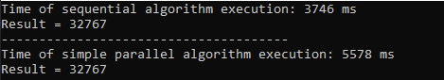

* **Размер 1000000:** 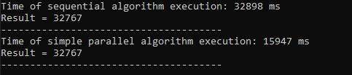
* **Размер 10000000:**